We need your help! Please help your little turkey make their way to safety this Thanksgiving! In order to help your turkey stay safe this holiday season, they will need an excellent disguise! Think of things like favorite movie characters, book characters, celebrities, other animals, objects, etc. and disguise your turkey accordingly!

Have fun and be creative! You may use any supplies you would like to decorate your turkey (glitter, pompoms, cotton balls, twigs, leaves, macaroni noodles, pipe cleaners, fabric, ribbons, feathers, and tissue paper are just a few ideas to get you started.)

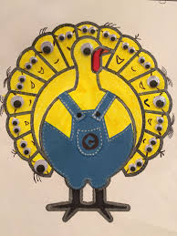
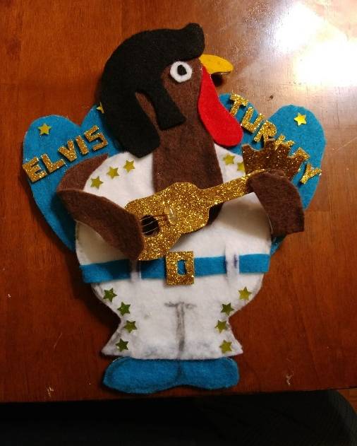
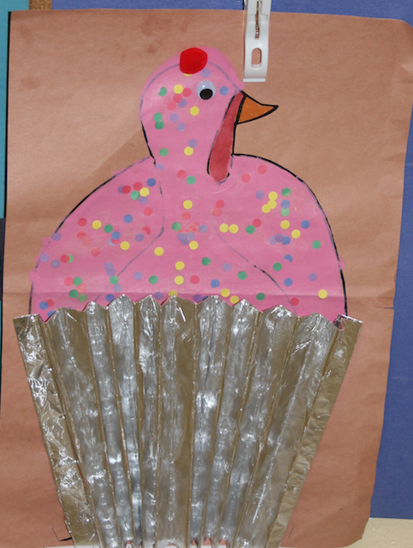
In addition to disguising your little turkey friend, students must write an accompanying narrative. Attached you will find a pre-writing organizer to help students organize their thoughts, as well as the rubric used to grade this assignment. Students should include things such as who/what they disguise their turkey as, why their turkey thinks they will be safe for Thanksgiving

