My Turkey in Disguise

Name: ________________________________________________________

My turkey is disguised as ________________________________________________

I think my turkey will be safe at Thanksgiving because…

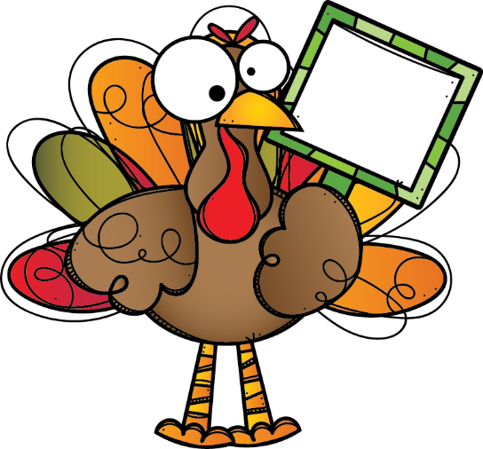
HELP
ME!

