Name __________________________

Date ___________________________

**Unit 1 Math Pre-Assessment: Creating Routines Using Data**

**Directions:** Your teacher will read all the questions and answer choices to you aloud. Circle or write the answer below each question.

1. Fill in the missing numbers on the lines below. (MGSE1.NBT.1) (DOK 1) (4 pts.)

1. 42, 43, ______, 45, ______
2. 112, ______, 114, ______, ______, ______

Write the number that is one less than the given number.

1. 36 ______
2. 119 ______
3. Count by ones to fill in the missing numbers. (MGSE1.NBT.1) (DOK 1) (2 pts.)

|  |  |  |  |  |  |  |  |  |  |
| --- | --- | --- | --- | --- | --- | --- | --- | --- | --- |
|  |  | **62** |  |  |  |  |  |  |  |
|  |  |  |  | **74** |  |  |  |  | **79** |

1. Explain how to find the number 84 on the chart below. (MGSE1.NBT.1) (DOK 3) (2 pts.)

[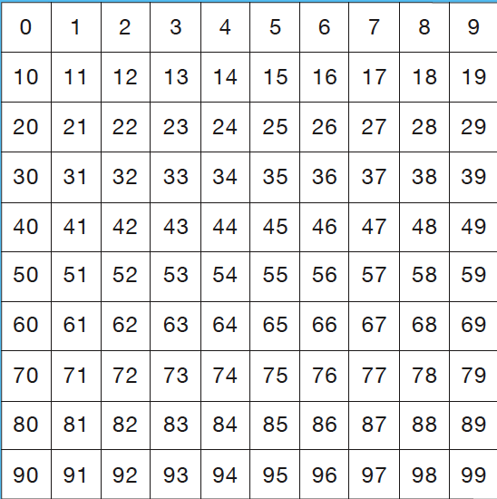](http://www.google.com/url?sa=i&rct=j&q=99+chart+for+math&source=images&cd=&cad=rja&docid=MZ0mh6kDLXaSbM&tbnid=itc526uXYD55pM:&ved=0CAUQjRw&url=http://finallyinfirst.blogspot.com/2012_06_01_archive.html&ei=ZZLpUdmxMIyE9gSj1oAQ&bvm=bv.49478099,d.eWU&psig=AFQjCNEMUj_h0SDPCJkwyPfKGeLBkOanag&ust=1374348190124762)

1. What number does each set below represent? (MGSE1.NBT.1)

(DOK 1) (2 pts.)

1. OOOOOOOOOO

OOOOOOOOOO _________________

OOOOOOOOOO

OOOOOO

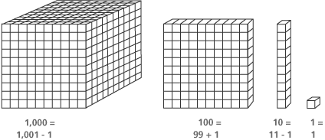[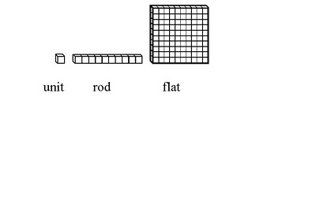](http://www.google.com/url?sa=i&rct=j&q=base+10+blocks&source=images&cd=&cad=rja&docid=58hcuHkWRQmGbM&tbnid=ozmzBpQ7ESaUIM:&ved=0CAUQjRw&url=http://poeticlicensedk.blogspot.com/2010/02/john-van-de-walle-elementary-school_18.html&ei=L5XpUf64Moje9ASC5YCICQ&bvm=bv.49478099,d.eWU&psig=AFQjCNHPCOVyNucygK71lpKNemO5VOioPA&ust=1374348961131226)

[](http://www.google.com/url?sa=i&rct=j&q=base+10+blocks&source=images&cd=&cad=rja&docid=58hcuHkWRQmGbM&tbnid=ozmzBpQ7ESaUIM:&ved=0CAUQjRw&url=http://poeticlicensedk.blogspot.com/2010/02/john-van-de-walle-elementary-school_18.html&ei=L5XpUf64Moje9ASC5YCICQ&bvm=bv.49478099,d.eWU&psig=AFQjCNHPCOVyNucygK71lpKNemO5VOioPA&ust=1374348961131226)

1. [](http://www.google.com/url?sa=i&rct=j&q=base+10+blocks&source=images&cd=&cad=rja&docid=58hcuHkWRQmGbM&tbnid=ozmzBpQ7ESaUIM:&ved=0CAUQjRw&url=http://poeticlicensedk.blogspot.com/2010/02/john-van-de-walle-elementary-school_18.html&ei=L5XpUf64Moje9ASC5YCICQ&bvm=bv.49478099,d.eWU&psig=AFQjCNHPCOVyNucygK71lpKNemO5VOioPA&ust=1374348961131226) __________________
2. Use numbers, pictures, and or words to show the number below 2 different ways. (MGSE1.NBT.1) (DOK 1) (2 pts.)

**12**

**1st Way:**

**2nd Way:**

**Use the chart below to answer questions 6-8.**

|  |  |  |
| --- | --- | --- |
| **LUNCH CHOICES** | **TALLY MARKS** | **TOTAL** |
| C:\Users\neumeisterp\AppData\Local\Microsoft\Windows\Temporary Internet Files\Content.IE5\4534BT9Q\MC900441748[1].pngC:\Users\neumeisterp\AppData\Local\Microsoft\Windows\Temporary Internet Files\Content.IE5\BK17FS7O\MC900441775[1].png Pizza |  | 7 |
| Sandwich |  | 4 |
| C:\Users\neumeisterp\AppData\Local\Microsoft\Windows\Temporary Internet Files\Content.IE5\L62T2JDT\MC900048792[1].wmf Spaghetti |  | 3 |

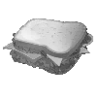

6.) How many children chose the sandwich? (MGSE1.MD.4) (DOK 1) (1 pt.)

* 1. 3 children
  2. 4 children
  3. 7 children
  4. 11 children

7.) How many more children chose pizza than spaghetti, and how do you know? (MGSE1.MD.4) (DOK 3) (1 pt.)

1. 4 children because 3 – 7 = 4
2. 4 children because 7 – 3 = 4
3. 7 children because 7 children chose pizza
4. 10 children because 7 + 3 = 10

|  |  |  |
| --- | --- | --- |
| **LUNCH CHOICES** | **TALLY MARKS** | **TOTAL** |
| C:\Users\neumeisterp\AppData\Local\Microsoft\Windows\Temporary Internet Files\Content.IE5\4534BT9Q\MC900441748[1].pngC:\Users\neumeisterp\AppData\Local\Microsoft\Windows\Temporary Internet Files\Content.IE5\BK17FS7O\MC900441775[1].png Pizza |  | 7 |
| Sandwich |  | 4 |
| C:\Users\neumeisterp\AppData\Local\Microsoft\Windows\Temporary Internet Files\Content.IE5\L62T2JDT\MC900048792[1].wmf Spaghetti |  | 3 |

8.) Which of the following statements is true when looking at the data? (MGSE1.MD.4) (DOK 2) (1 pt.)

1. More students chose pizza than spaghetti and a sandwich
2. 4 more students chose pizza than a sandwich
3. One more student chose spaghetti than a sandwich
4. Fewer students chose a sandwich than pizza

Mrs. Murray surveyed her students to learn the number of pets each student has. She learned that 10 students have a dog, 7 students have a cat, and 4 students have a fish.

|  |  |  |
| --- | --- | --- |
| **Mrs. Murray’s Class: Pets** | | |
| **PET** | **TALLY MARKS** | **TOTAL** |
| Dog |  |  |
| Cat |  |  |
| Fish |  |  |

9.) Complete the tally chart below. (MGSE1.MD.4) (DOK 1) (3 pts.)

1. How many students did Mrs. Murray survey? (MGSE1.MD.4) (DOK 1) (1 pt.)

_________________________________________

**Unit 1 Pre-Assessment: Creating Routines Using Data**

**Answer Key**

1. a.) 44, 46

b.) 113, 115, 116, 117

c.) 35

d.) 118

1. Check for correct answers according to each row (1 pt. each row)

|  |  |  |  |  |  |  |  |  |  |
| --- | --- | --- | --- | --- | --- | --- | --- | --- | --- |
| **60** | **61** | **62** | **63** | **64** | **65** | **66** | **67** | **68** | **69** |
| **70** | **71** | **71** | **73** | **74** | **75** | **76** | **77** | **78** | **79** |

1. Answers should include mention of locating the row of 8 in the tens place and or locating the column of 4 and looking down 8 rows.
2. a.) 36

b.) 114

1. Answers include: twelve, 12 objects or tally marks drawn
2. B
3. B
4. D

|  |  |  |
| --- | --- | --- |
| Mrs. Murray’s Class: Pets | | |
| PET | TALLY | TOTAL |
| Dog | IIII IIII | 10 |
| Cat | IIII II | 7 |
| Fish | IIII | 4 |

1. 21 students